The week in 7 charts
5th of October 2026

------------------------------------------------------------------------------------------------------------------------------

Chart #1: Will France Sovereign debt rating soon drop into “junk” territory?

Based on the relationship between sovereign ratings and spreads over Germany, France’s current spread of 135 basis points is consistent with a BBB- rating, the lowest investment-grade notch on the S&P scale.

In other words, France now stands just one notch above “junk” territory.

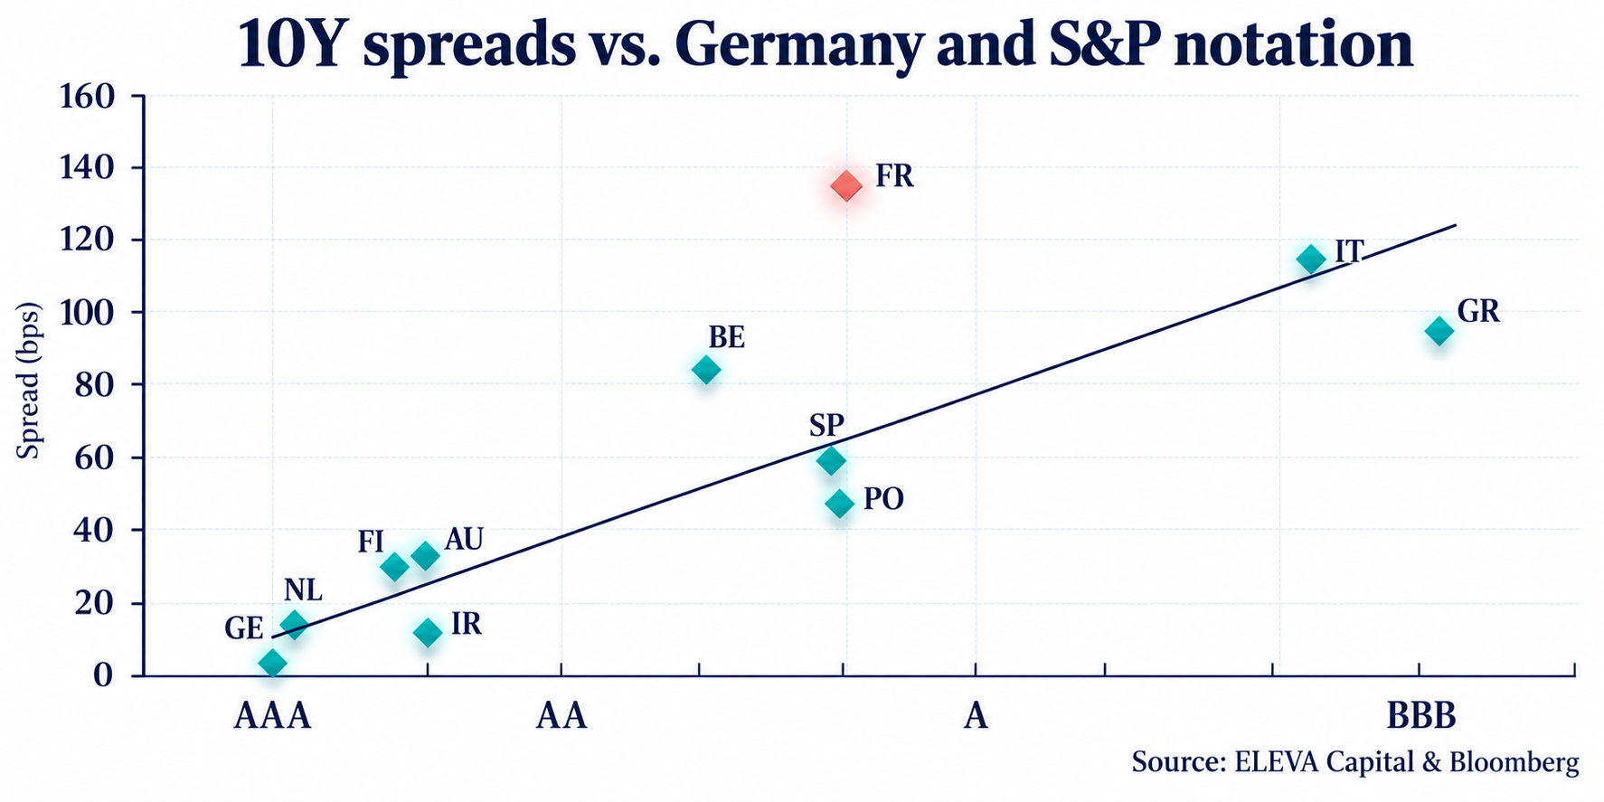

Source: Bloomberg, Eleva capital

Chart #2: 🚀 Anthropic at $2 trillion: outrageous—or a bet on extraordinary growth?

The IPO prospectus, which has reportedly leaked, presents two contrasting pictures.

The first concerns spending: an operating loss of $8 billion in 2025 and over $500 billion of future commitments, around 80% of which are reportedly non-cancelable.

The second concerns growth:
▪️ Revenue in 2025: $4.6 billion
▪️ Annualized run rate in July 2026: $65 billion
▪️ Revenue forecast for 2028: $200 billion

A $2 trillion valuation therefore implies:
👉 435x 2025 revenue
👉 31x the July annualized run rate
👉 10x forecast 2028 revenue

However, a run rate is not the same as annual revenue, and a forecast is not a result.

Can July’s performance be repeated, or was it inflated by exceptionally large contracts? Two customers reportedly accounted for a quarter of 2025 revenue, with no long-term commitment in place.

Each new projection makes the valuation easier to justify. The real test lies in converting those projections into actual revenue.

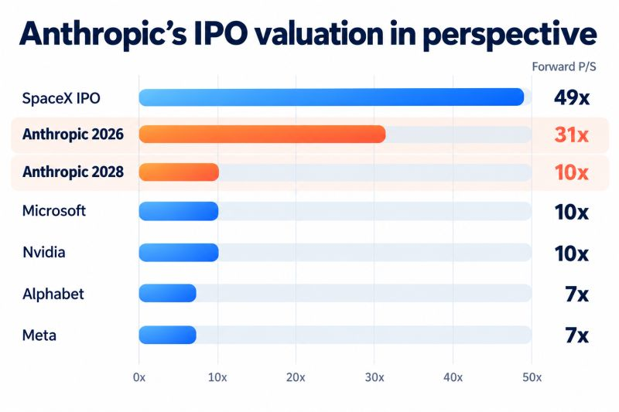
Source: Dan Runkevicius

Chart #3: A new valuation metric for US stocks?

The White House has just released the seating chart for its Super Intelligence Luncheon.

Does proximity to Trump signal greater perceived upside? 📈

Wall Street studies earnings reports closely. It may want to study the seating plan as well.

🥇 Jensen Huang (Nvidia) and Elon Musk (Tesla/X): seated directly next to Trump.
🥈 Mark Zuckerberg (Meta) and Sundar Pichai (Google): separated from him by a single seat.
▪️ Satya Nadella (Microsoft): still close at hand.
▪️ Jeff Bezos (Amazon): a little further along the table.
▪️ Hock Tan (Broadcom) and Sanjay Mehrotra (Micron): further removed.
▪️ Dario Amodei (Anthropic): toward the far end.
▪️ Greg Brockman (OpenAI): on the opposite side, several seats along.

Could distance from the president become a new valuation metric? 😉

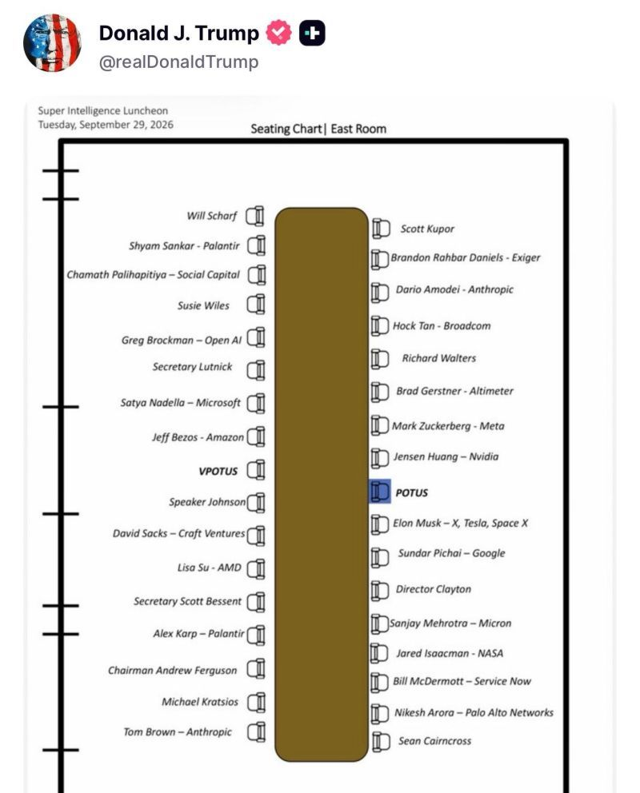

Source: Manish Singh

Chart #4: The longest duration Treasury bond ETF is now down 67% from its peak in March 2020

How did this happen? The 30-year Treasury yield has risen from a record low of 0.8% in March 2020 to 5.6% today.

Long duration + rates rising from record lows = heavy losses

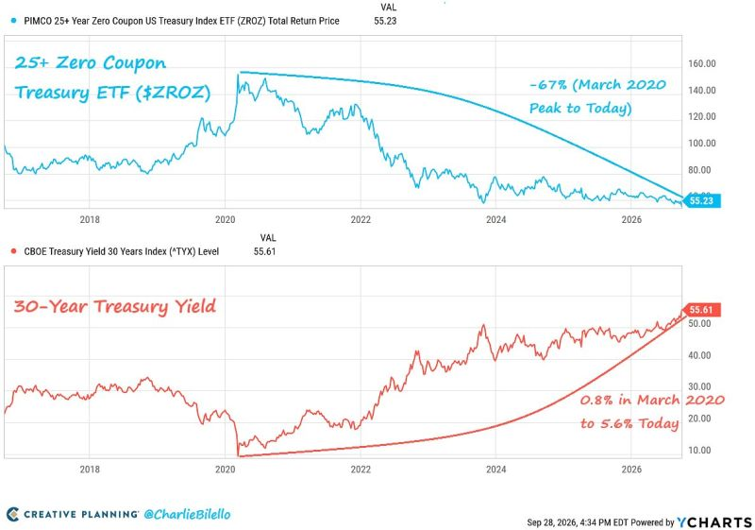

Source: Charlie Bilello

Chart #5: Democrats might be able to win both houses at US mid-term elections

Polymarket now shows the Democrats (in blue) as favorites to regain both the Senate (63% probability) and the House (93% probability) in the midterm elections, their highest odds so far.

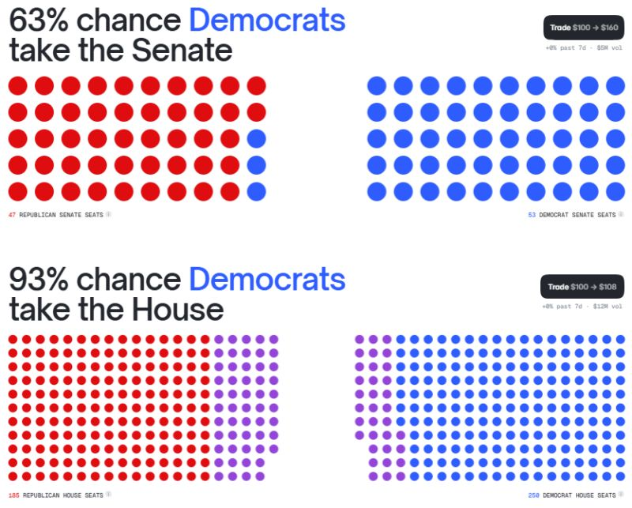

Source: Polymarkets

Chart #6: Trump’s current approval rating is the lowest in recent history

At 37%, President Trump’s job approval rating is the lowest recorded for any president ahead of a midterm election (polling data available since 1990).

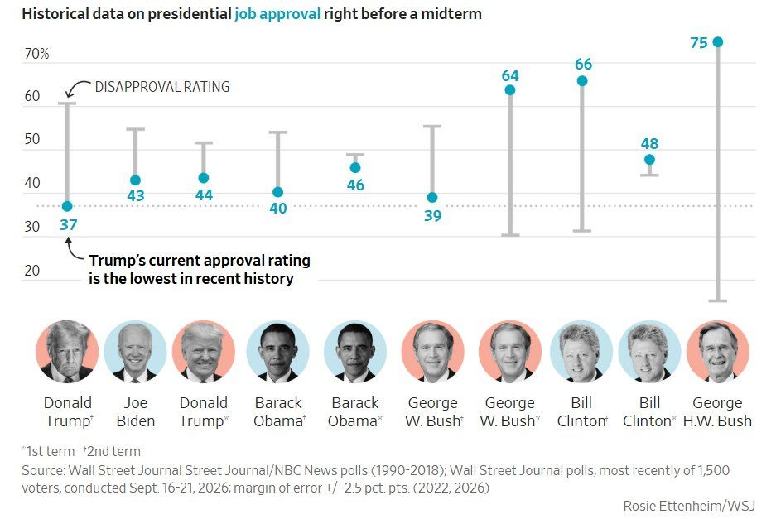

Source: Charlie Bilello

Chart #7: ⌚ Four watches. $49.4 million. All for charity.

Rolex’s “Four Seasons” auction was held in London, with an exceptional outcome.

Sold individually by Phillips, the four one-of-a-kind Cosmograph Daytona watches fetched a combined $49,467,260, a new record for a charity watch sale.

The individual results:
☀️ Summer: $13.6 million
🍂 Autumn: $13.5 million
❄️ Winter: $13.2 million
🌸 Spring: $9 million

Each piece represents one season, combining precious metals, natural-stone dials and striking gemstones.

The full proceeds will go to the Federer Foundation and Re, supporting children’s access to education and the protection of ecosystems around the world.

It was the combination of rarity, craftsmanship and the Rolex name that drew collectors in.

Yet the true value of these bids will be measured by the lives and landscapes they help to transform.

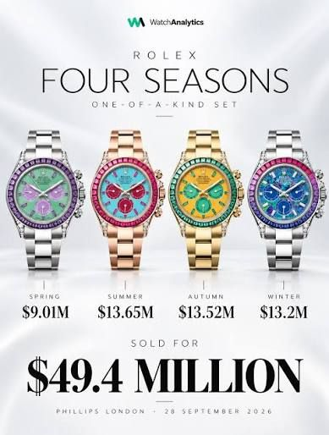

Source: Watch Analytics

